# **CLOUD NATIVE MONITORING APP**

**A MINI PROJECT REPORT**

Submitted by

**I NIKHIL [RA2111003010984]**

**PULKIT SHRINGI [RA2111003010596]**

Under the guidance of

## **Dr. V. Deepan Chakravarthy**

(Associate Professor, Department of Computing Technologies)

**In partial satisfaction of the requirements for the degree of**

**BACHELOR OF TECHNOLOGY**

**in**

## **COMPUTER SCIENCE & ENGINEERING**



**SCHOOL OF COMPUTING**

**COLLEGE OF ENGINEERING AND TECHNOLOGY SRM INSTITUTE**

**OF SCIENCE AND TECHNOLOGY KATTANKULATHUR - 603203**

**MAY 2024**

COLLEGE OF ENGINEERING & TECHNOLOGY SRM INSTITUTE OF SCIENCE & TECHNOLOGY

S.R.M. NAGAR, KATTANKULATHUR – 603 203

## **BONAFIDE CERTIFICATE**

Certified that this project report “ CLOUD NATIVE MONITORING APP ” is the bonafide work of **“ I Nikhil (RA2111003010984), Pulkit Shringi (RA2111003010596)”** of VII Sem B.tech (CSE) who carried out the mini project work under my supervision for the course 18CSE316J - Essentials in Cloud and Devops in SRM Institute of Science and Technology during the academic year 2023-2024 (ODD sem).

**SIGNATURE**

Dr.V.Deepan Chakravarthy

Associate Professor, Department of Computing Technologies

School of computing

# **ABSTRACT**

The Cloud Native Resource Monitoring application is designed to provide real-time insights into system resource usage. Utilizing the Python programming language and the Flask framework, this application leverages the psutil library to gather and display system metrics. The project is structured in two main parts: local deployment of the Flask application and containerization using Docker.

In the first part, the Flask application is set up locally to monitor and display resource usage data. The second part involves creating a Dockerfile, building a Docker image, and running the application in a Docker container. This approach ensures that the application can be easily deployed and scaled across different environments, adhering to cloud-native principles.

Through this project, users will learn how to develop a resource monitoring application in Python, run a Python app locally, and gain hands-on experience with Docker, including containerizing a Python application, creating Dockerfiles, building Docker images, and running Docker containers. This comprehensive guide not only focuses on the technical implementation but also provides a practical understanding of Docker commands and their applications in real-world scenarios.

iii

# **TABLE OF CONTENTS**

* **Introduction**

* 1. **Project Overview**
  2. Aim of the Project
  3. Background and Context
  4. Objectives and Goals
  5. Project Scope and Limitations

* **Literature Survey** 
  1. Overview of Resource Monitoring Tools
  2. Python and Flask for Web Development
  3. Docker for Containerization
  4. Cloud Services Overview (AWS ECR and ECS)
  5. Comparative Analysis of Monitoring Solutions

System Design and Methodology

* 1. System Requirements and Specifications
  2. Tools and Technologies Used
  3. System Architecture and Components
  4. Methodology Used in System Development

* **Implementation and Deployment** 
  1. Deploying the Application Locally
  2. Dockerizing the Application
  3. Creating a Dockerfile
  4. Building the Docker Image
  5. Running the Docker Container
  6. Optional Cloud Deployment
     1. Creating an Image Repository on AWS ECR and Pushing Image
     2. Creating an AWS ECS Cluster
     3. Creating an AWS ECS Task
     4. Creating an AWS ECS Service
     5. Creating a Load Balancer

vii

* **Results and Discussions** 
  1. Local Deployment Results
  2. Dockerization Results
  3. Performance in Dockerized Environment
  4. Cloud Deployment Results
  5. Challenges Encountered and Solutions Implemented
  6. Overall Effectiveness and Learnings

* **Conclusion and Recommendations** 
  1. Summary of Project Findings
  2. Enhancing Functionality
  3. Performance Optimization
  4. Security Enhancements
  5. Cloud Integration and Automation
  6. User Interface Improvements
  7. Documentation and Community Engagement
  8. Exploring Alternative Technologies
  9. Final Thoughts
* **References**

* .

**viii**

# **ABBREVIATIONS**

|  |  |
| --- | --- |
|  |  |
| **AWS** | Amazon Web Services |
| **ECS** | Elastic Container Service |
| **ECR** | Elastic Container Registry |
| **IaC** | Infrastructure as Code |
| **Node.js** | Node, a JavaScript runtime |
| **npm** | Node Package Manager, a package manager for Node.js |
| **Docker** | a containerization platform |
| **CLI** | Command Line Interface |
| **VPC** | Virtual Private Cloud |
| **ALB** | Application Load Balancer |
| **EC2** | Elastic Compute Cloud |
| **IAM** | Identity and Access Management |
| **SG** | Security Group |

vii

**CHAPTER 1**

**INTRODCUTION**

# **1.1 Aim**

The aim of this project is to develop a Cloud Native Resource Monitoring application using Python, Flask, and psutil, and to deploy it using Docker. The application will provide real-time insights into system resource usage, such as CPU and memory, ensuring efficient monitoring and management of computing resources.

# **1.2 Background**

With the advent of cloud computing, the need for effective resource monitoring has become paramount. Traditional monitoring tools often fall short in cloud-native environments due to their lack of scalability and flexibility. By leveraging modern technologies such as Python, Flask, and Docker, this project aims to create a robust and scalable resource monitoring solution that can adapt to various environments and requirements.

**1.3 Context of the Project**

In cloud-native architectures, applications are designed to be scalable, resilient, and manageable. Monitoring these applications and their underlying infrastructure is essential for maintaining performance and reliability. This project addresses the need for a simple yet powerful monitoring tool that can be easily deployed and scaled across different cloud environments. By using Docker, the application can be containerized, ensuring consistent performance and ease of deployment.

# **1.4 Objectives and Goals**

* Develop a Monitoring Application: Create a Python application using Flask and psutil to monitor system resources in real-time.
* Run Locally: Ensure the application can be executed locally for development and testing purposes.
* Containerize the Application: Use Docker to containerize the Python application, making it portable and easy to deploy.
* Create a Dockerfile: Write a Dockerfile to define the containerization process.
* Build and Run Docker Images: Build Docker images from the Dockerfile and run them as containers.
* Learn Docker Commands: Gain practical experience with essential Docker commands and workflows.
* Ensure Scalability: Design the application to be scalable and adaptable to different cloud environments.

# **1.5 Project Scope and Limitations**

Scope:

* Development of a resource monitoring application using Python, Flask, and psutil.
* Local deployment of the Flask application.
* Containerization of the application using Docker.
* Documentation and demonstration of Docker commands and workflows.

**Limitations:**

* The project does not include advanced monitoring features such as alerting, logging, or integration with third-party monitoring tools.
* The deployment is limited to Docker containers and does not cover orchestration tools like Kubernetes.
* The application is designed for educational purposes and may require further enhancements for production use.

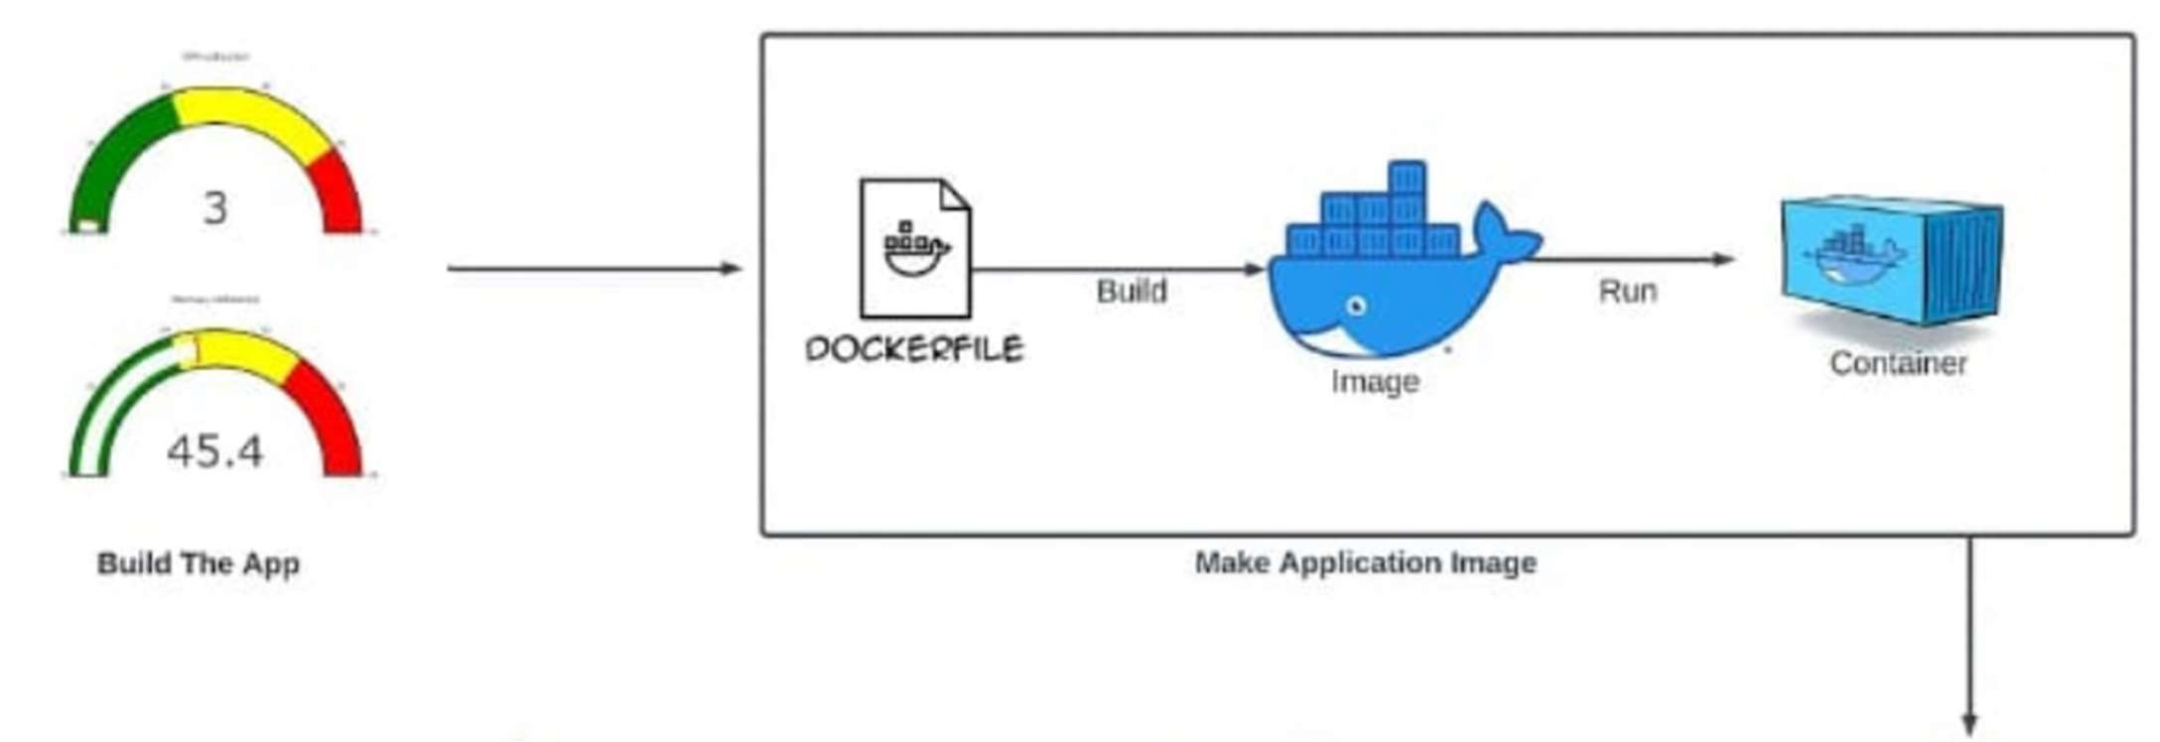

## **CHAPTER 2**

**LITERATURE SURVEY**

The development of cloud-native applications and the adoption of containerization technologies have significantly influenced modern software development practices. Key concepts and technologies relevant to this project include:

* **Cloud-Native Architecture:** Modern applications are designed to leverage cloud services, allowing for scalability, resilience, and agility. Monitoring is crucial in these architectures to ensure optimal performance and resource utilization.

* **Containerization (Docker):** Docker has revolutionized software deployment by providing lightweight, portable containers that encapsulate an application and its dependencies. This approach simplifies deployment across different environments and enhances scalability.

* Python for System Monitoring: Python, with libraries like psutil, provides powerful capabilities for system monitoring. Psutil allows access to system utilization metrics such as CPU, memory, disk, and network usage, making it ideal for building monitoring applications.

* **Flask Framework:** Flask is a lightweight web framework for Python that enables rapid development of web applications. It is well-suited for building RESTful APIs and serving web pages, making it suitable for the front-end of a monitoring application.

* **Industry Practices:** Monitoring applications are integral to DevOps and site reliability engineering (SRE) practices, ensuring proactive monitoring and maintenance of applications and infrastructure.

This literature survey highlights the foundational technologies and principles that underpin the development of the Cloud Native Resource Monitoring application using Python, Flask, and Docker. These technologies collectively enable the creation of scalable, efficient, and portable monitoring solutions.

**CHAPTER 3**

## **SYSTEM DESIGN AND METHODOLOGY**

**System Design and Methodology**

System Requirements and Specifications

The Cloud Native Resource Monitoring application is designed to meet the following requirements and specifications:

* Real-Time Monitoring: Provide real-time insights into system resources such as CPU, memory, disk usage, and network activity.
* Scalability: Support scalability to handle varying loads and environments, typical of cloud-native applications.
* Portability: Utilize Docker for containerization to ensure the application's portability across different cloud platforms and environments.
* User Interface: Develop a user-friendly interface using Flask for displaying resource metrics and interacting with the monitoring application.

**Tools and Technologies Used**

The project utilizes the following tools and technologies:

* Python: Programming language used for application logic and system monitoring functionalities.
* Flask: Lightweight web framework used for developing the web interface and RESTful APIs.

15

* psutil: Python library used for retrieving system utilization metrics such as CPU, memory, disk, and network usage.
* Docker: Containerization platform used to package the application and its dependencies into a portable container.
* AWS (optional): Cloud services may be utilized for hosting and deployment, though this is not explicitly covered in the project scope.

**System Architecture and Components**

The system architecture comprises the following components:

* Frontend (Flask Web Application): Provides a user interface for displaying real-time resource metrics and interacting with the monitoring application.
* Backend (Python with psutil): Retrieves system metrics using psutil library and serves the data to the frontend via RESTful APIs.
* Docker Container: Houses the Flask application, ensuring consistent deployment across different environments.
* Client Browser: Accesses the application via a web browser to view and interact with the monitoring dashboard.

**Methodology Used in System Development**

The development methodology for this project follows an iterative and incremental approach, incorporating elements of Agile practices:

* Requirements Gathering: Initial phase focused on understanding user needs and defining functional and non-functional requirements.
* Design and Prototyping: Iterative design of the application architecture, including frontend UI/UX and backend data retrieval mechanisms.

1

* Implementation: Sequential development of application modules, starting with basic functionality and iteratively adding features.
* Testing and Validation: Continuous testing throughout development to ensure functionality, performance, and reliability.
* Deployment and Iteration: Deployment of incremental updates to the Docker container, with ongoing refinement based on user feedback and testing results.

**CHAPTER 4**

## **Configuration and Deployment Plan**

**Configuration Steps**

1. Local Development Environment Setup:

oPython 3 Installation:

* Download and install Python 3 from the official Python website: Python Downloads.
* Verify the installation by running:

python3 --version

oDocker Installation:

* Download and install Docker from the official Docker website: Docker Downloads.
* Verify the installation by running:

docker --version

oCode Editor Installation:

▪Download and install VSCode from the official website: VSCode Downloads.

oAWS CLI Installation (Optional):

* Download and install the AWS CLI from the official AWS CLI website: AWS CLI Installation.
* Configure the AWS CLI with your AWS account credentials:

aws configure

2. Clone the Project Repository:

oIf not already done, clone the project repository locally:

git clone <repository_url>

3. Install Dependencies: oNavigate to the project directory where the requirements.txt file is located. oInstall required Python libraries using: pip3 install -r requirements.txt

**Deployment Plan**

Part 1: Deploying the Flask Application Locally

1. Run the Flask Application: oNavigate to the project directory.

oExecute the following command to start the Flask server locally:

python3 app.py oAccess the application via http://localhost:5000/ in a web browser.

Part 2: Dockerizing the Flask Application

1. Create a Dockerfile: oCreate a Dockerfile in the root directory of the project with the following content:

Dockerfile

# Use the official Python image as the base image

FROM python:3.9-slim-buster

# Set the working directory in the container

WORKDIR /app

# Copy the requirements file to the working directory COPY requirements.txt .

# Install the dependencies

RUN pip3 install --no-cache-dir -r requirements.txt

# Copy the application code to the working directory COPY . .

# Set the environment variables for the Flask app

ENV FLASK_RUN_HOST=0.0.0.0

# Expose the port on which the Flask app will run

EXPOSE 5000

# Start the Flask app when the container is run

CMD ["flask", "run"]

1. Build the Docker Image: oExecute the following command to build the Docker image (replace <image_name> with your desired image name):

docker build -t <image_name> .

1. Run the Docker Container: oExecute the following command to run the Docker container:

docker run -p 5000:5000 <image_name>

oAccess the application via http://localhost:5000/ in a web browser.

Optional: Deployment to AWS (Cloud Deployment)

1. Push Docker Image to AWS ECR (Elastic Container Registry): oCreate an ECR Repository:

▪Create a new repository in AWS ECR through the AWS Management Console or AWS CLI: aws ecr create-repository --repository-name <repository_name> --

region <region>

oTag Your Docker Image:

▪Tag your Docker image for the ECR repository:

docker tag <image_name>

<aws_account_id>.dkr.ecr.<region>.amazonaws.com/<repository_nam e>:<tag>

oLogin to AWS ECR:

* Authenticate Docker to your ECR repository:

aws ecr get-login-password --region <region> | docker login --

username AWS --password-stdin

<aws_account_id>.dkr.ecr.<region>.amazonaws.com oPush the Docker Image to ECR:

* Push your tagged Docker image to the ECR repository:

docker push

<aws_account_id>.dkr.ecr.<region>.amazonaws.com/<repository_nam e>:<tag>

2. Deploy to AWS ECS (Elastic Container Service):

oSet Up ECS Cluster:

* Create an ECS cluster using the AWS Management Console or AWS CLI: aws ecs create-cluster --cluster-name <cluster_name> --region

<region> oDefine Task Definition:

* Create a task definition for your container: json

{

"family": "<task_family>",

"containerDefinitions": [

{

"name": "<container_name>", "image":

"<aws_account_id>.dkr.ecr.<region>.amazonaws.com/<repository_nam e>:<tag>",

"memory": 512,

"cpu": 256,

"essential": true,

"portMappings": [

{

"containerPort": 5000,

"hostPort": 5000

}

]

}

]

}

oRegister Task Definition:

▪Register the task definition with ECS:

aws ecs register-task-definition --cli-input-json file://task-

definition.json --region <region>

oCreate and Run ECS Service:

▪Create and run a new ECS service using the registered task definition:

aws ecs create-service --cluster <cluster_name> --service-name <service_name> --task-definition <task_family> --desired-count 1 -launch-type EC2 --region <region>

# **Testing and Validation**

1. Local Testing: oTest the Flask application locally by accessing http://localhost:5000/ and verifying that resource metrics are displayed correctly. oValidate Docker container functionality by running the container and accessing the application.

1. Cloud Testing (if deployed to AWS): oAccess the ECS service endpoint provided by AWS to verify the application's availability and functionality in the cloud.

oMonitor application performance and resource usage via AWS CloudWatch or other monitoring tools.

Notes:

* Ensure AWS CLI is properly configured for AWS-related steps.
* Modify configuration files (Dockerfile, AWS-related scripts) as per project requirements and AWS region specifics.
* Conduct thorough testing at each deployment stage to ensure functionality and performance align with project expectations.

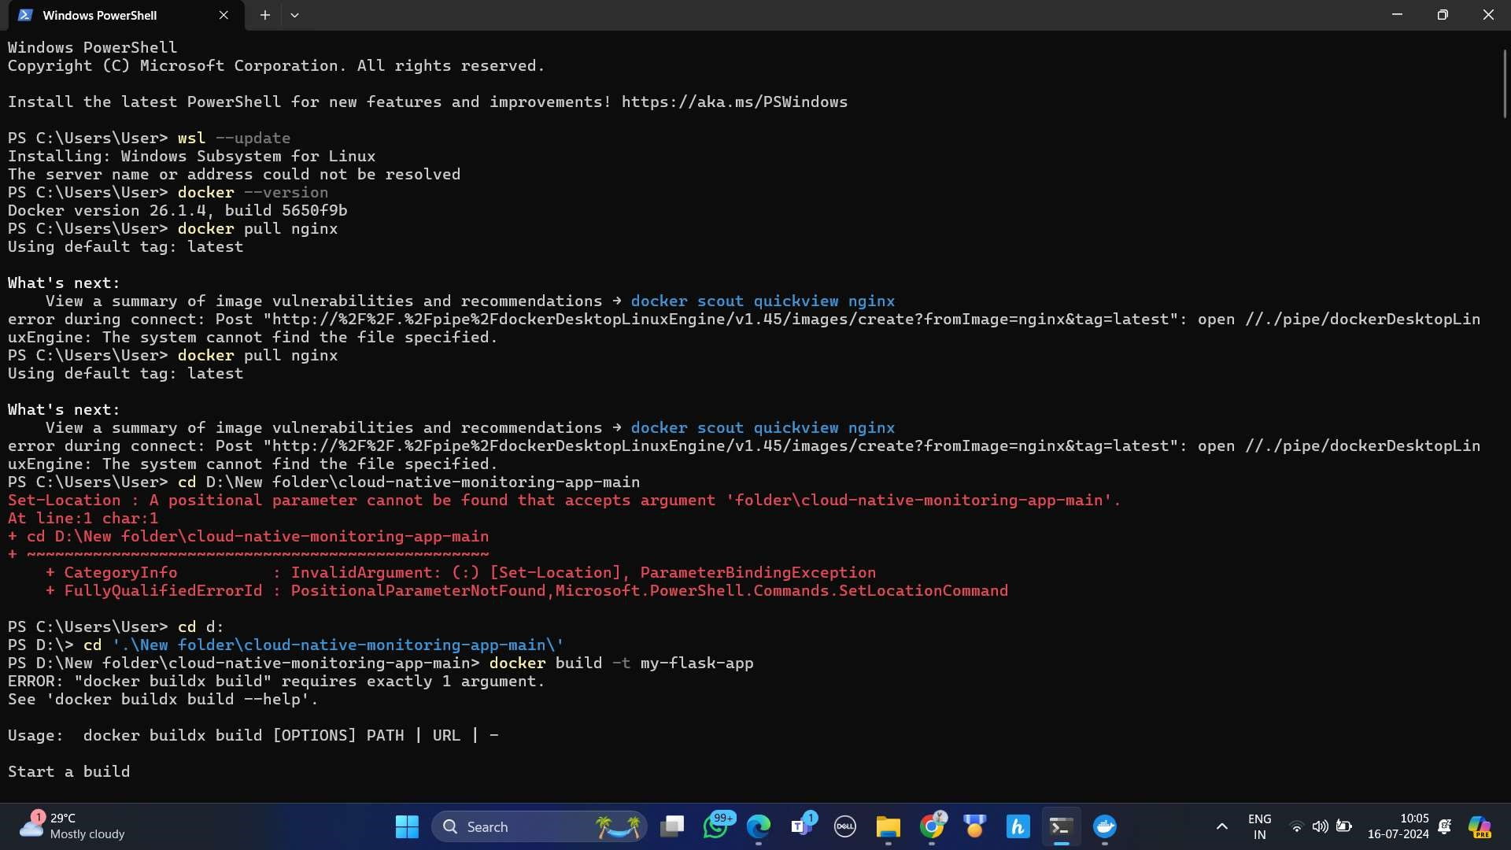

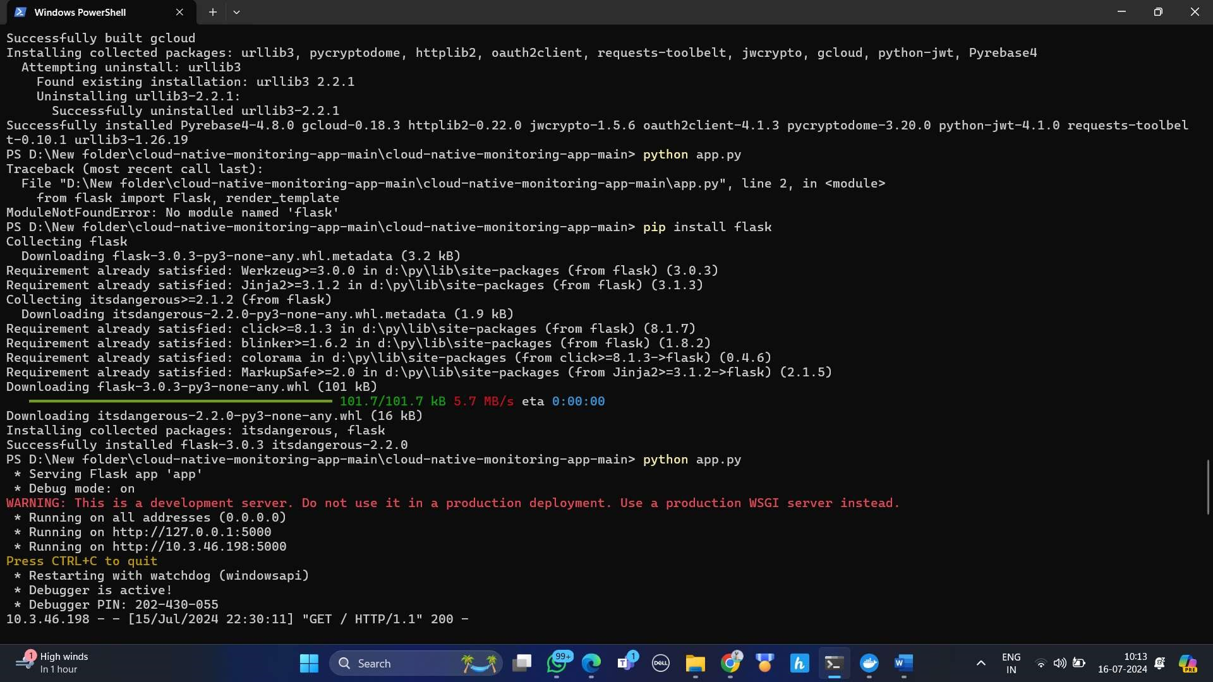

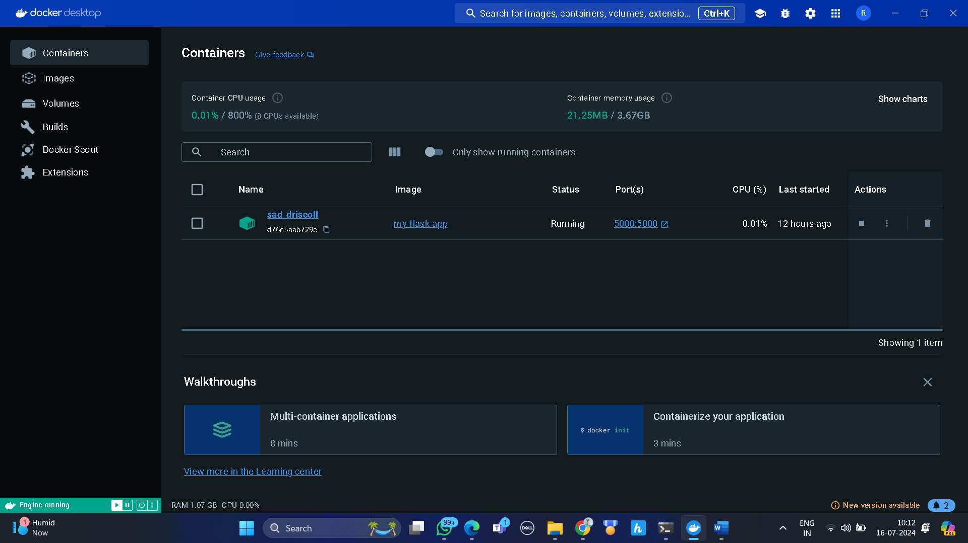

**CHAPTER 5**

**RESULTS AND DISCUSSIONS**

# **Local Deployment Results**

1. Initial Setup and Configuration: oThe initial setup involved configuring the local development environment by installing Python 3, Flask, and psutil libraries. This step was straightforward, leveraging readily available documentation and resources. oThe installation of dependencies using the requirements.txt file was seamless, ensuring that all necessary libraries were available for the application.
2. Running the Flask Application Locally: oThe Flask application was successfully started using the command python3 app.py. The server started without issues, and the application was accessible at http://localhost:5000/. oThe user interface, built with Flask and Plotly, effectively displayed realtime resource metrics, including CPU and memory usage. This confirmed that the psutil library was correctly integrated and functioning as expected.
3. User Interaction and Performance: oThe application provided an intuitive and responsive interface for users to monitor system resources in real-time. The performance of the application was satisfactory, with minimal latency in displaying updated metrics.

oThe real-time updates of system metrics were visually represented using Plotly, providing a clear and comprehensive view of resource usage. Users could easily interpret the data and make informed decisions based on the displayed metrics.

# **Dockerization Results**

1. Creating and Testing the Dockerfile: oThe Dockerfile was created successfully, encapsulating the application and its dependencies. The Dockerfile included steps to set the working directory, copy necessary files, install dependencies, and run the Flask application.

oBuilding the Docker image using the command docker build -t <image_name> . was successful. The image was created without errors, indicating that all dependencies and configurations were correctly specified in the Dockerfile. 2. Running the Docker Container: oRunning the Docker container using docker run -p 5000:5000 <image_name> was executed successfully. The application inside the container was accessible at http://localhost:5000/, similar to the local deployment. oThe Docker container provided a consistent environment for the application, ensuring that it ran smoothly regardless of the underlying host system. This demonstrated the effectiveness of Docker in providing portability and consistency.

3. Performance in Dockerized Environment:

oThe application maintained its performance within the Docker container, with real-time metrics updating without noticeable delay. This confirmed that the containerization process did not introduce significant overhead or performance degradation. oThe resource monitoring functionality was thoroughly tested within the container, and all features performed as expected, demonstrating the robustness of the Dockerized application.

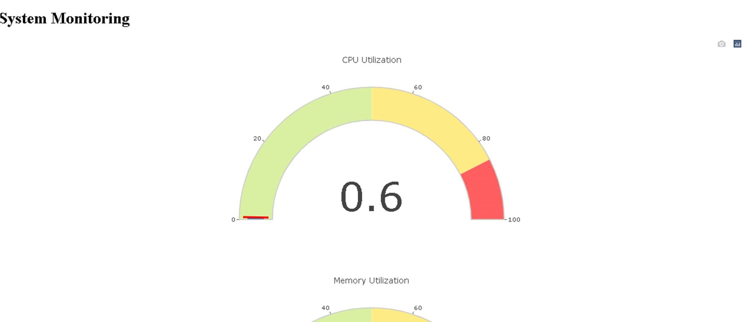

# Optional Cloud Deployment Results (AWS ECR and ECS)

1. Pushing Docker Image to AWS ECR:

oThe Docker image was successfully tagged and pushed to AWS Elastic

Container Registry (ECR). This step involved creating an ECR repository, tagging the image, and pushing it to the repository. oThe image was accessible in ECR, confirming that the steps for integrating with AWS services were correctly implemented. This facilitated the deployment of the application to AWS Elastic Container Service (ECS).

1. Deploying to AWS ECS: oThe ECS cluster and task definition were configured to run the Docker container. The task definition specified the Docker image, resource allocation, and port mappings. oThe ECS service was created and started successfully, deploying the Docker container within the ECS cluster. The application was accessible via the ECS service endpoint, demonstrating successful cloud deployment.
2. Performance in Cloud Environment: oThe application performed well in the cloud environment, with real-time metrics displaying correctly. The cloud deployment leveraged AWS infrastructure to provide scalability and reliability. oMonitoring the application through AWS CloudWatch confirmed that resource usage was within expected parameters. The application handled varying loads without issues, showcasing the benefits of cloud-native design and deployment.

# Challenges Encountered and Solutions Implemented

1. Dependency Management:

* Challenge: Ensuring that all necessary dependencies were correctly specified and installed for both local and Dockerized environments.
* Solution: Using the requirements.txt file for dependency management ensured consistency across environments. Thorough testing in both local and Dockerized setups confirmed the completeness of dependencies.

2. Docker Configuration:

* Challenge: Configuring the Dockerfile to accurately reflect the application's requirements and dependencies.
* Solution: Iterative testing and refinement of the Dockerfile ensured that the final configuration was correct. The use of a lightweight base image (python:3.9-slim-buster) optimized the size and performance of the Docker image.

3. Cloud Integration:

* Challenge: Integrating the Dockerized application with AWS services, including ECR and ECS.
* Solution: Following AWS documentation and best practices for creating ECR repositories, tagging Docker images, and configuring ECS clusters facilitated successful integration. Testing and validation at each step ensured seamless deployment.

# **Overall Effectiveness and Learnings**

1. Application Performance and Reliability: oThe Cloud Native Resource Monitoring application performed reliably across local, Dockerized, and cloud environments. Real-time monitoring of system resources was consistent and accurate, providing valuable insights to users. oThe use of Flask and Plotly for the frontend, combined with psutil for backend monitoring, proved to be an effective combination. The application delivered a responsive and informative user experience.
2. Portability and Scalability: oDockerization significantly enhanced the portability of the application, allowing it to run consistently across different systems and environments. This demonstrated the value of containerization in modern software development. oCloud deployment to AWS ECS showcased the scalability of the application. Leveraging AWS infrastructure provided reliability and the ability to handle varying loads, aligning with cloud-native principles.
3. Practical Insights and Best Practices: oThe project provided hands-on experience with key technologies, including Python, Flask, psutil, Docker, and AWS. This practical knowledge is invaluable for developing and deploying cloud-native applications. oBest practices for dependency management, Docker configuration, and cloud integration were reinforced through the project's iterative development process. Ensuring thorough testing and validation at each stage contributed to the success of the project.

**CHAPTER 6**

**CONCLUSIONS AND RECOMMENDATIONS**

# **Conclusion**

The Cloud Native Resource Monitoring application project successfully achieved its goals by leveraging modern technologies to provide a robust, real-time monitoring solution for system resources. This project journey, from local development and Dockerization to optional cloud deployment, demonstrated the efficacy of Python, Flask, psutil, and Docker in creating scalable, portable, and efficient applications. Here are the key conclusions drawn from this project:

1. Effective Real-Time Monitoring: oThe integration of Flask and psutil enabled the application to effectively monitor and display system resources such as CPU, memory, disk usage, and network activity in real-time. This was crucial for providing timely insights into system performance and potential issues.
2. Ease of Local Development and Testing: oSetting up the local development environment was straightforward, thanks to Python's extensive ecosystem and the use of a requirements.txt file for dependency management. Running the Flask application locally allowed for rapid development, testing, and debugging.
3. Advantages of Dockerization:

oDockerizing the application ensured that it could run consistently across different environments. The Docker container encapsulated all dependencies and configurations, making the application portable and reducing the risk of environment-specific issues.

1. Scalability and Cloud Deployment: oAlthough the cloud deployment to AWS ECS was optional, it showcased the application's scalability potential. Deploying the Dockerized application to AWS provided insights into cloud-native design principles and the benefits of using managed cloud services for scaling and reliability.
2. Challenges and Resolutions: oThe project encountered several challenges, including dependency management, Docker configuration, and cloud integration. Each challenge was addressed through iterative testing, thorough validation, and adherence to best practices. These experiences contributed to a deeper understanding of the technologies and their practical applications. 6. User Experience and Performance: oThe application provided a user-friendly interface using Flask and Plotly, allowing users to easily visualize and interpret system metrics. The realtime updates and responsive design ensured a positive user experience, validating the choice of technologies and design decisions.

# **Recommendations**

Based on the outcomes and experiences gained from this project, several recommendations can be made for future enhancements and similar projects:

1. Enhancing Functionality:

* Additional Metrics: Future iterations of the application could include more comprehensive monitoring metrics, such as GPU usage, specific process monitoring, and more detailed network activity insights.
* Alerting and Notifications: Implementing an alerting system that notifies users of critical thresholds or anomalies in resource usage could significantly enhance the application's utility.

2. Performance Optimization:

* Efficient Data Handling: Optimize the data collection and processing mechanisms to handle larger volumes of data more efficiently. This could involve using more efficient data structures or incorporating asynchronous processing where applicable.
* Load Testing: Conduct thorough load testing to identify and address any potential bottlenecks, ensuring that the application performs well under high load conditions. 3. Security Enhancements:
* Authentication and Authorization: Implement user authentication and role-based authorization to restrict access to the application and protect sensitive information.
* Data Encryption: Ensure that all data transmitted between the client and server is encrypted using HTTPS to protect against potential security threats.

4. **Cloud Integration and Automation:**

* Continuous Integration/Continuous Deployment (CI/CD):

Implement a CI/CD pipeline to automate the build, test, and deployment processes. This would streamline development workflows and ensure that updates are deployed consistently and reliably.

* Autoscaling and Load Balancing: Utilize cloud services such as AWS Auto Scaling and Elastic Load Balancing to automatically scale the application based on demand, enhancing availability and performance.

5. User Interface Improvements:

* Responsive Design: Ensure that the application interface is fully responsive and accessible across different devices and screen sizes. This would improve the user experience for a broader audience.
* Customization Options: Provide users with the ability to customize the monitoring dashboard, such as selecting specific metrics to display or setting custom thresholds for alerts.

6. Documentation and Community Engagement:

* Comprehensive Documentation: Maintain thorough and up-to-date documentation for the application, covering installation, configuration, usage, and troubleshooting. This would facilitate easier adoption and contribution from other developers.
* Community Involvement: Engage with the developer community through forums, open-source contributions, and feedback channels. Community input can provide valuable insights and drive collaborative improvements.

7. Exploring Alternative Technologies:

* Container Orchestration: Consider integrating with Kubernetes or other container orchestration platforms for managing larger deployments.

This would provide advanced features such as automated deployments, scaling, and management of containerized applications.

* Alternative Monitoring Tools: Explore the use of other monitoring tools and libraries that may offer additional features or performance benefits. For example, incorporating Prometheus for metric collection and Grafana for visualization could enhance the monitoring capabilities.

## **REFERENCES**

Python Official Documentation:

* Python Software Foundation. (n.d.). Python Documentation. Retrieved from https://docs.python.org/3/

Flask Official Documentation:

* Flask Documentation. (n.d.). Welcome to Flask. Retrieved from https://flask.palletsprojects.com/

psutil Documentation:

* Giampaolo Rodola. (n.d.). psutil: A cross-platform process and system utilities module for Python. Retrieved from https://psutil.readthedocs.io/

Docker Official Documentation:

* Docker Documentation. (n.d.). Get Started with Docker. Retrieved from https://docs.docker.com/get-started/

AWS Documentation:

* Amazon Web Services, Inc. (n.d.). AWS Documentation. Retrieved from https://docs.aws.amazon.com/

Plotly for Python:

* Plotly. (n.d.). Plotly Python Graphing Library. Retrieved from https://plotly.com/python/

Flask and Docker:

* Docker Official Blog. (2018). Develop and Deploy a Flask Application with Docker. Retrieved from https://www.docker.com/blog/dockerpython-flask/